Package in python

A package is a container that contains various functions to perform specific tasks. For example, the [math](https://www.programiz.com/python-programming/modules/math) package includes the sqrt() function to [perform the square root of a number](https://www.programiz.com/python-programming/examples/square-root).

While working on big projects, we have to deal with a large amount of code, and writing everything together in the same file will make our code look messy. Instead, we can separate our code into multiple files by keeping the related code together in packages.

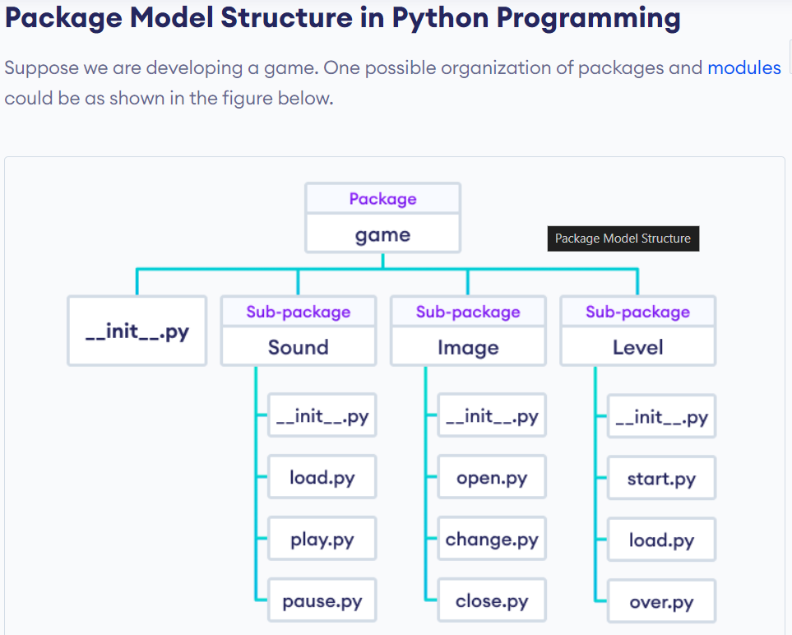

**How to Create Package in Python?**

Creating packages in Python allows you to organize your code into reusable and manageable modules. Here’s a brief overview of how to create packages:

* **Create a Directory:** Start by creating a directory (folder) for your package. This directory will serve as the root of your package structure.
* **Add Modules:** Within the package directory, you can add Python files (modules) containing your code. Each module should represent a distinct functionality or component of your package.
* **Init File:** Include an __init__.py file in the package directory. This file can be empty or can contain an initialization code for your package. It signals to Python that the directory should be treated as a package.
* **Subpackages:** You can create sub-packages within your package by adding additional directories containing modules, along with their own __init__.py files.
* **Importing:** To use modules from your package, import them into your Python scripts using dot notation. For example, if you have a module named module1.py inside a package named mypackage, you would import its function like this: from mypackage.module1 import greet.
* **Distribution:** If you want to distribute your package for others to use, you can create a setup.py file using Python’s setuptools library. This file defines metadata about your package and specifies how it should be installed.

Example:-

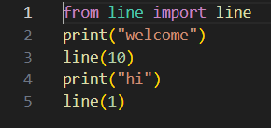

Output:-

